Ideation Phase
Define the Problem Statements

Date | 12 October 2026
Team ID: | SWUID2026403825
Project Name | StaffSync - Modern human resource management solution
Maximum Marks | 2 Marks

Customer Problem Statement Template:
To identify the core problems HR teams and employees face while managing employee records, attendance, leave requests, and workplace communication, and use those insights to guide the development of StaffSync.
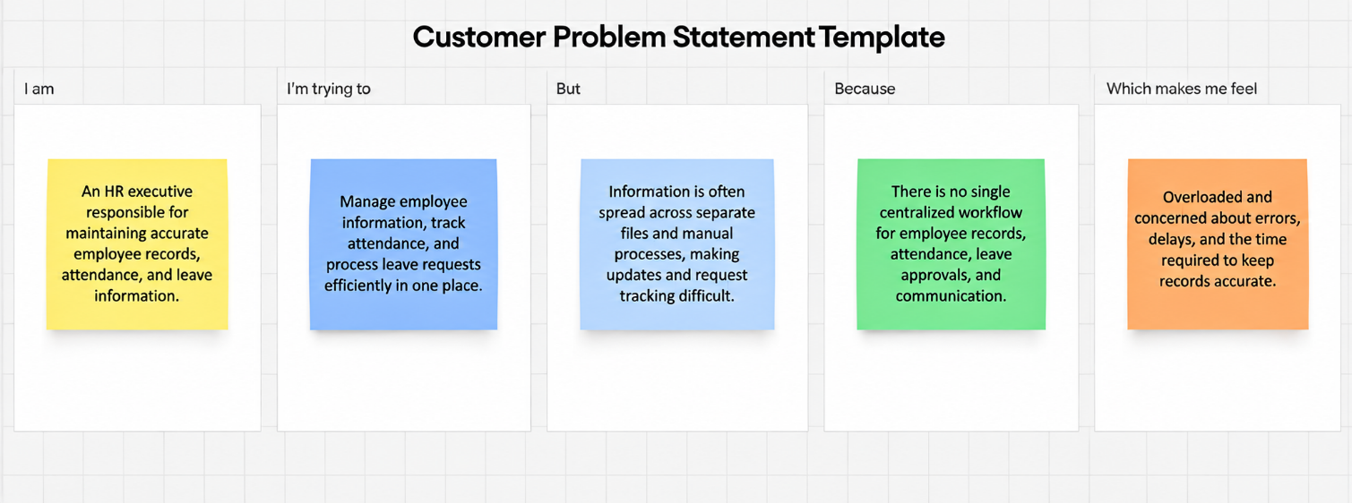
Reference: https://miro.com/templates/customer-problem-statement/

Problem Statement (PS) | I am (Customer) | I’m trying to | But | Because | Which makes me feel
PS-1 | HR executive | manage employee records, attendance, and leave requests efficiently | information is spread across separate files and manual processes | updates and follow-ups take time and can lead to inconsistent records | overloaded and concerned about accuracy
PS-2 | employee | check attendance and track leave request status easily | updates are not always visible in one central place | they must contact HR or managers repeatedly for information | uncertain and frustrated by delays

